Understanding the Enneagram
by Dr. John D. Ferrer (18 Dec 2022)
- What is the Enneagram?
- Introduction: Derived from the Latin ennea meaning “9” the Enneagram is a 9-sided symbol that’s come to be associated with personality profiling. The American Journal of Psychiatry defines the Enneagram as: “a personality theory describing nine strategies by which the psyche develops a worldview and relates to self and others.” Each point in the design represents a specific personality type. The Journal adds that each line is a relation between those types. Each type is identified with a “basic fear, basic desire, and a predictable pattern of behavior in times of stress and security.” Plus, there are wings, subtypes, and unnumerable predictions and interpretations available as the symbol is thought to offer limitless insight. The Enneagram Institute proposes 9 personality types. |  |  | 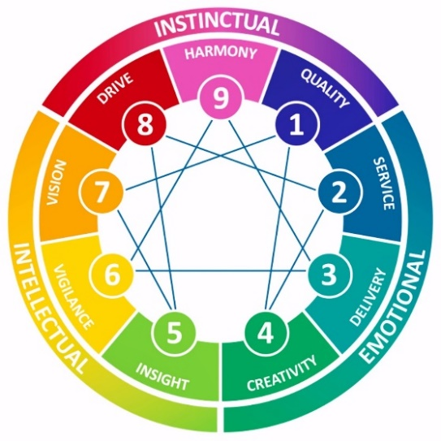  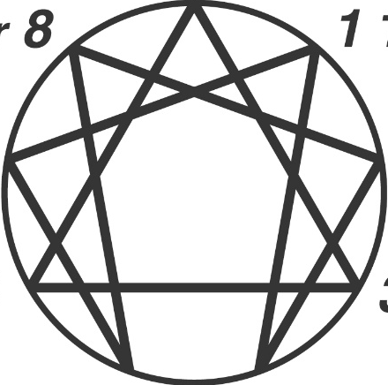  Image courtesy of  Christ United Methodist Church Plano, TX.  Image Courtesy of  The Enneagram Institute 2005.
- The Reformer – the rational, idealistic type: principled, purposeful, self-controlled, and perfectionistic
- The Helper – the caring, interpersonal type: demonstrative, generous, people-pleasing, and possessive
- The Achiever – the success-oriented, pragmatic type: adaptive, excelling, driven, and image-conscious
- The Individualist – the sensitive, withdrawn type: expressive, dramatic, self-absorbed, and temperamental
- The Investigator – the intense, cerebral type: perceptive, innovative, secretive, and isolated
- The Loyalist – the committed, security-oriented type: engaging, responsible, anxious, and suspicious
- The Enthusiast – the busy, fun-loving type: spontaneous, versatile, distractible, and scattered.
- The Challenger – the powerful, dominating type: self-confident, decisive, willing, and confrontational.
9. The Peacemaker – the easygoing, self-effacing type: receptive, reassuring, agreeable, and complacent.
- Cultural Significance | 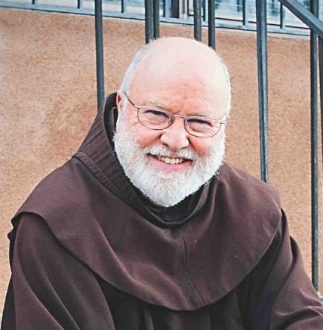  The Enneagram was popular in some Catholic communities in the 1970’s owing to Richard Rohr, a Franciscan mystic and New Age spiritualist. Implementing a “mystical retreat” vibe, his seminars appealed to many theological liberals, counterculturalists, and hippies. By 1991, Helen Palmer published The Enneagram and its popularity surged, attracting clients with its versatility and explanatory scope. Soon followed the Enneagram Institute founded in 1997. As the internet became a new dimension of culture in the early 2000’s, social media sprouted, smart phones proliferated, and screen-based culture fueled digitally enhanced narcissism. The market for personality testing exploded. The enneagram’s elaborate theories and promised empowerment proved too tempting to pass up. In recent years, corporations began using it for employee assessments. Liberal protestant churches also gravitated towards it’s humanistic and self-help elements. Mainline evangelicals eventually joined the crowd, becoming its largest client base today.  Richard Rohr  Picture courtesy of Broadview
- What’s the good side? | It promotes self-awareness and there’s nothing inherently wrong with personality studies. Also, while the personality system isn’t especially credible or wise, it can still be valuable in the same sense as a broken machine. The machine might not work, but it’s parts can still be useful. Lastly, it defies secular humanism by endorsing spirituality and affirming a supernatural realm.
- What’s the bad side? | Critics argue that it’s (1) Historically Idolatrous, (2) Scientifically Baseless, (4) Theologically Tenuous, (4) Practically Useless, and (5) Spiritually Dangerous.
1. Historically  Idolatrous  *The section is drawn largely from Veinot & Montenegro’s, Richard Rohr and the Enneagram Secret (2020), pgs. 57-68, and supplemented by The Enneagram Institute, “the Traditional Enneagram,” pg. 1 | - The Enneagram began around 1900 and never ceased being occult idolatry. From its inception till now, it’s been handed down, one occultist to another in an unbroken chain of custody.
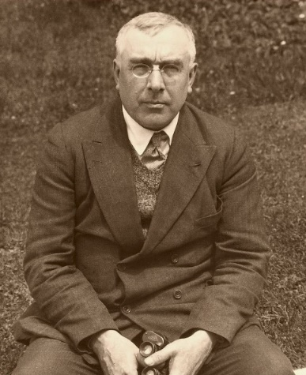
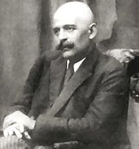
- This symbol is first mentioned around 1900AD by Russian occultist P.D. Ouspensky (1878-1947). He attributes it to his mentor, Greco-Russian occultist Georges Gurdjieff (1866/77-1949). Formerly Eastern Orthodox, Gurdjieff became a fixture in the New Age movement by founding a New Thought cult called the Fourth Way. He saw the enneagram as the mystical key to every door saying “all knowledge can be included in the enneagram and with the help of the enneagram it can be interpreted. . . . only what a man is able to put into the enneagram does he actually know . . . Everything can be included and read in the enneagram.” (Ouspensky, In Search of the Miraculous, 1950, pg294). That sweep includes all laws of the universe, all esoteric meanings, all occult insights. Neither Gurdjieff nor his disciple Ouspensky focused that universal scope on personality study. Nevertheless, they predicted that every truth of personality is contained in the enneagram.
George Gurdjieff. Source: Wikipedia
Peter D. Ouspensky
Source: Ouspensky Today
 | - Perhaps the first to derive personality theory from the enneagram was Rodney Collin in 1954. A disciple of Ouspensky, he derived 9 enneagram personality types corresponding with astrological signs. Around that time, occultist Oscar Ichazo (1931-2020) brought those ideas to Bolivia where he founded the Arica institute. Ichazo framed his personality theory within eastern mysticism, New Age, and a bit of Freudian psychoanalysis. One student of Ichazo, the New Age spiritualist, Claudio Naranjo (1932-2019), distilled Ichazo’s thoughts into roughly the enneagram model we have today. He did it through automatic writing (a form of demonic-possession; i.e., spiritism). Naranjo introduced the Enneagram to the Esalen Institute (New Age think tank in CA). There Bob Ochs, Mitch Pacwa, and Richard Rohr, all Roman Catholic churchmen, bought in and began promoting it, originally in Catholic circles, but spreading from there. Today, Rohr is the leading enneagram recruiter.
2. Scientifically Baseless | - Scientifically speaking the enneagram is somewhere between guess-work and pseudo-science
2. Scientifically Baseless | - The best that could be said for it scientifically is it has “mixed evidence of reliability and validity.” (Hook, et al., “Enneagram: A Systematic Review” Jour. Of Clin. Psych. 2020, pg. 1). That’s a polite way of saying, it’s not scientifically credible, but some clinicians still use it.
2. Scientifically Baseless | - To have compelling scientific merit, the enneagram would need to produce consistent results with accurate predictions, preferably in double-blind settings; and do all of that better than placebos (i.e., better predictions than random guessing). The Enneagram doesn’t do that.
2. Scientifically Baseless | - It’s buried beneath occult baggage as long as it lacks that scientific merit. Unsurprisingly, research psychologist Jay Mendenwalt says, “It's a no-brainer . . . the enneagram simply cannot do all its proponents claim it can. Any scientist who studies personality would simply look at the reliability scores and conclude the test is not accurate enough to be helpful, and . . . wouldn't use it because the potential for harm will be too high” (Enneagram Pt 1 Jan2019).
2. Scientifically Baseless | - Note that personality studies rest within the “soft-sciences” (psychology & sociology). They struggle to attain the “hard” scientific support found in other fields (physics, chemistry, etc.). Yet even among these soft-targets the enneagram isn’t accurate enough to pass muster.
2. Scientifically Baseless | - For scientifically credible personality studies there are better options like the Big5 (Big Five Inventory), MMPI (Minnesota Multiple Personality Inventory), or StrengthsFinder (Gallup).
3. Theologically Tenuous | - Scripture counsels us to not just obey God’s commands but also be wise about everything else too (Matt 10:16; Phil 1:9). The enneagram fails on both counts.
3. Theologically Tenuous | - Lacking natural and scientific credibility, those who trust the enneagram have to rely on faith more than reason. But it’s not a proper object of faith, especially with its occult baggage.
3. Theologically Tenuous | - Definition: Occult – “hidden/secret.” In medical terms, “occult blood” means blood you can’t see. In religious studies “occult” refers to secret, typically forbidden, power or knowledge. Three occult fields are divination (deriving knowledge from ‘signs’), spiritism (spirit-communication), and magic (sorcery). | d. Deut. 18:9-14 “There shall not be found among you anyone . . . who practices divination or tells fortunes or interprets omens, or a sorcerer or a charmer or a medium or a necromancer or one who inquires of the dead, for whoever does these things is an abomination to the Lord.”
3. Theologically Tenuous | e. Understood as occultism, the enneagram is a kind of divination, so it’s forbidden (Deut. 18:9-14). This prohibition makes sense, given the deeply human habit of idolatry, in this case, occult fascination. People are easily tempted by promises of self-knowledge and personal empowerment even through forbidden channels. Yet, in following those forbidden paths we’re believing the same lie Satan told Eve, “You will not surely die. For God knows that when you eat of it your eyes will be opened, and you will be like God” (Gen 3:4-5). Eve was tempted to disobey God to attain god-like knowledge. Tellingly, enneagram teachers even refer to one’s ideal image as a “divine self.” |  |  | f. Verses on Occultism:  Ex. 22:18  Lev. 19:26,31; 20:6,27  Deut. 18:9-14  1 Sam 15:23  2 Kings 21:6; 23:24  1 Chron 10:13-14  2 Chron. 33:6  Isa 8:19  Micah 5:12  Gal 5:19-21  2 Thess 2:9  Rev. 21:8; 22:15
3. Theologically Tenuous | - Occult practice overlaps with idolatry. And there is a mountain of historical evidence testifying to why we need to take occult influence seriously. In the NT Paul warns his audience to “flee from idolatry” (1 Cor 10;14). Across the OT Israel shows why believers need that warning. Israel was constantly returning to occultism and idolatry across the wilderness wanderings (Exod.-Deut.), in the time of the Judges (Joshua, Judges, Ruth), in the early monarchy (1-2 Samuel), spanning the late monarchy (Kings, Chron.). The Prophetic books were laced throughout with calls for God’s people to repent of occult compromise, and pagan ways (Isa-Mal.). The all-to-human habit of occult fascination is a live threat for all of us.
3. Theologically Tenuous | - The enneagram doesn’t have to be implicated in Israel’s idolatry, or our own, to still be dangerous. It can be as innocuous as an first dose, a “gateway” drug at the front end of skid row. This little bit of divination can desensitize people by shaping their frame of thought, inserting itself into our deeply held beliefs, and introducing key words and concepts that settle in and stretch our worldview in unbiblical directions.
3. Theologically Tenuous | - For anyone who is serious about serving God only, they have plenty of reason to be leery of the enneagram. It’s tied to astrology (Collin), demonic possession (Naranjo), New Thought (Gurdjieff), and New Age (Rohr). But, even if we suppose that it’s not occult, is it at least a wise a practice? Again, no. Scripture implores us to stay above reproach and not be a stumbling block for others (Rom 14; 1 Cor. 8:13; 2 Cor. 6:3). Moreover, our every action should be an act of worship, “as unto the Lord” (Col. 3:17). And we have much better ways to worship the Lord than by trying to salvage a divination tool from a pile of heretical trash.
4. Practically Useless: | - Some may argue that it “works” but are probably using “work” in a faulty sense. People are remarkably inventive when protecting a deeply held belief. Ex., downplaying contrary data, cherry-picking evidence, or giving charitable interpretation when it needs a rigorous critique.
4. Practically Useless: | - It’s not scientifically credible (see #2) as it works only as well as placebos. I.e., it doesn’t work.
4. Practically Useless: | - Whatever insights it may offer, they’re outweighed by dangerous misfires and occult baggage.
4. Practically Useless: | - Even horoscopes are “right” in a general sporadic way. Enneagram predictions work the same way as horoscopes by using squishy interpretation, sweeping generalities, unfalsifiable claims, and cherry picking evidence. Plus, people who believe their enneagram number tend to conform to it. What the enneagram lacks in predictive value, people replace by unwittingly “tampering with the evidence” making it look more accurate than it is.
5. Spiritually Dangerous: | - Enneagram advocates rely heavily on spirituality for its explanations and predictions, but since it’s not biblical or Christian spirituality, it’s problematic at best and idolatrous at worst.
5. Spiritually Dangerous: | - Scripture teaches “Christian liberty” wherein Christians have general permission for most anything that’s not sinful, immoral, or unwise (see, Rom 14; 1 Cor 6:12; Gal 5:13; 1 Pet 2:16). This might justify people’s use of the enneagram if it weren’t unreliable pseudo-science with historic ties to occult spirituality. As such, it’s too unwise to be fit Christian practice.
5. Spiritually Dangerous: | - Spiritually speaking, when we’re dabbling in occultism, whether it’s deliberate or accidental, we’re still inviting into our lives the same spiritual strongholds and unwanted guests. As such, we should err on the side of caution and stay away from it because it’s way too close to occultism to be a generally safe space for Christians. And for those who are already into the enneagram, we should lovingly encourage them to replace it with better options.
5. Spiritually Dangerous: | - Two big errors to be avoided. (1) We could be too soft on the enneagram, downplaying its dangers, doubting and denying uncomfortable truths about. We’d do this because we know people are committed to it and don’t want to upset them. That’s spiritual compromise for fear of “making waves." On the other end, (2) we could be too hard on the enneagram. We’d be overzealous alarmists, exaggerating the threat it poses, making false accusations labeling everything occult that’s not explicitly endorsed in Scripture. And we’d likely commit a lot of friendly fire with graceless hyper-vigilant attacks on anything that moves. Clearly, we should avoid these extremes. In searching for a spiritually discerning response we need to stay clear of them both. Yes, we should probably keep the enneagram out of churches wherever we can. But when church members are already involved with it, our response to them should be filled with grace, love, and wisdom. Think Golden Rule and the Rule of Love (Mt 7:12; Mk 12:30-31).
- Rebuttals
- But it’s not occult anymore. So, it’s okay, right?
It’s probably still occult and even if it weren’t, it’s still unreliable misinformation. Anyone serious about pursuing truth should avoid it. But remember, it was formed in occult mysticism, bathed in occult beliefs, infused with astrology (divination), and activated with symbol divination. The personality theory began in automatic writing (demonic possession) and it continues to be promoted and taught in New Age theology and Eastern mysticism. Even today, the more authoritative the enneagram teacher (like at the Enneagram Institute) the more blunt they are in admitting it’s occult status. If it had better scientific credentials, then it could stand on its merits as natural revelation or natural knowledge (like biology, math, etc.). But it doesn’t have that. So, the occult baggage remains.
- It’s not like we’re drawing pentagrams on the floor or conducting seances, so what’s the harm?
What’s the harm in taking a small bite of that fruit in the Garden? Even a little bite can do big harm. Likewise, what’s the harm in a little drink? It’s pretty dangerous for alcoholics, for minors, and especially if that little drink is laced with poison. It’s a fool’s errand to try to “dose out” our rebellion against God. God will not be mocked. And God has little patience for believers who should know better but downplay it and dabble in the occult anyway.
- Conclusion:
- There’s no explicit biblical-Christian permission for using the enneagram. Yet because of its history with occult spirituality we can’t safely assume it’s implicitly allowed under Christian liberty either (Rom 14; 1 Cor 6:12; Gal 5:13; 1 Pet 2:16). There’s no denying it “hung out with the wrong crowd” for most of its upbringing. But it never clearly moved out of that seedy neighborhood either. Overall, it’s wisest to avoid the enneagram.
- Two big questions loom over the enneagram: Is it occult? And is it accurate? If it is occult but also had scientific merit, then maybe the occultists just stumbled upon natural facts, truths about our nature, and it’s not rightfully “theirs” to claim as “occult.” But it doesn’t have that scientific merit. So, it can’t quite shed that occult baggage.
- Even if we give it a positive spin, thinking it’s personality system can be somehow separated from all the occult spirituality, we’re still left with a sub-par personality system so inaccurate that it borders on pseudo-science.
- One has to wonder then, why would people still gravitate toward this system when there are more credible options available like MMPI, Big5, and StrengthsFinder? If people are clinging to the enneagram and dismissing evidence of occultism while refusing to consider whether it’s even credible then it’s beginning to look like an idol, or at least a spiritual stronghold. The system is widely touted by its supporters as “spiritual” and “mystical,” but lacking any rightful Christian standing, that “spiritual” and “mystical” dimension ties it back into false religion. Again, it just can’t shed that occult baggage.

